DAY-2
1.Sum of row and column – Array
#include <stdio.h>
#define ROWS 3
#define COLS 3
int main() {
int arr[ROWS][COLS] = {
{1, 2, 3},
{4, 5, 6},
{7, 8, 9}
};
int row_sum[ROWS];
int col_sum[COLS];
for (int i = 0; i < ROWS; i++) {
row_sum[i] = 0;
for (int j = 0; j < COLS; j++) {
row_sum[i] += arr[i][j];
}
}
for (int j = 0; j < COLS; j++) {
col_sum[j] = 0;
for (int i = 0; i < ROWS; i++) {
col_sum[j] += arr[i][j];
}
}
printf("Row sums: ");
for (int i = 0; i < ROWS; i++) {
printf("%d ", row_sum[i]);
}
printf("\n");
printf("Column sums: ");
for (int j = 0; j < COLS; j++) {
printf("%d ", col_sum[j]);
}
printf("\n");
return 0;
}
OUTPUT:
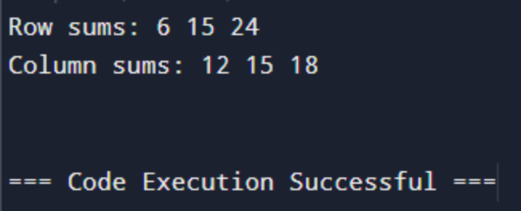
2.Elements repeated twice – Array
#include <stdio.h>
#define SIZE 10
int main() {
int arr[SIZE] = {1, 2, 3, 4, 2, 7, 8, 8, 3, 6};
int count[SIZE] = {0};
for (int i = 0; i < SIZE; i++) {
for (int j = 0; j < SIZE; j++) {
if (arr[i] == arr[j]) {
count[i]++;
}
}
}
printf("Elements repeated twice: ");
for (int i = 0; i < SIZE; i++) {
if (count[i] == 2) {
printf("%d ", arr[i]);
}
}
printf("\n");
return 0;
}
OUTPUT:

3.Write a C program to perform Matrix Multiplication
#include <stdio.h>
#define ROWS_A 2
#define COLS_A 3
#define COLS_B 2
void multiply_matrices(int a[ROWS_A][COLS_A], int b[COLS_A][COLS_B], int result[ROWS_A][COLS_B]) {
for (int i = 0; i < ROWS_A; i++) {
for (int j = 0; j < COLS_B; j++) {
result[i][j] = 0;
for (int k = 0; k < COLS_A; k++) {
result[i][j] += a[i][k] * b[k][j];
}
}
}
}
void print_matrix(int matrix[ROWS_A][COLS_B]) {
for (int i = 0; i < ROWS_A; i++) {
for (int j = 0; j < COLS_B; j++) {
printf("%d ", matrix[i][j]);
}
printf("\n");
}
}
int main() {
int a[ROWS_A][COLS_A] = {
{1, 2, 3},
{4, 5, 6}
};
int b[COLS_A][COLS_B] = {
{7, 8},
{9, 10},
{11, 12}
};
int result[ROWS_A][COLS_B];
multiply_matrices(a, b, result);
printf("Matrix A:\n");
print_matrix(a);
printf("Matrix B:\n");
print_matrix(b);
printf("Result:\n");
print_matrix(result);
return 0;
}
OUTPUT:
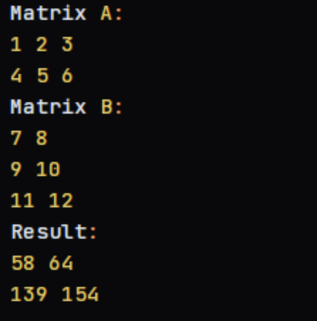
4. Factorial of a given number without using Recursion
#include <stdio.h>
int factorial(int n) {
int result = 1;
for (int i = 1; i <= n; i++) {
result *= i;
}
return result;
}
int main() {
int num;
printf("Enter a number: ");
scanf("%d", &num);
if (num < 0) {
printf("Error: Factorial is not defined for negative numbers.\n");
} else {
int fact = factorial(num);
printf("Factorial of %d is: %d\n", num, fact);
}
return 0;
}
OUTPUT:
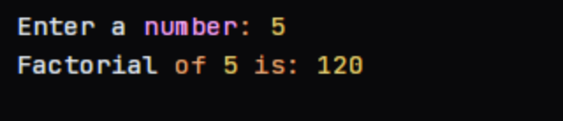
5.Fibonacci series without using Recursion
#include <stdio.h>
void fibonacci(int n) {
int t1 = 0, t2 = 1, nextTerm = 0;
printf("Fibonacci Series: ");
for (int i = 1; i <= n; ++i) {
printf("%d, ", t1);
nextTerm = t1 + t2;
t1 = t2;
t2 = nextTerm;
}
printf("\n");
}
int main() {
int n;
printf("Enter the number of terms: ");
scanf("%d", &n);
fibonacci(n);
return 0;
}
OUTPUT:
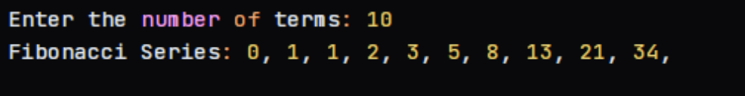
6.Factorial of a given number using Recursion
#include <stdio.h>
int factorial(int n) {
if (n == 0 || n == 1) {
return 1;
} else {
return n * factorial(n - 1);
}
}
int main() {
int num;
printf("Enter a number: ");
scanf("%d", &num);
if (num < 0) {
printf("Error: Factorial is not defined for negative numbers.\n");
} else {
int fact = factorial(num);
printf("Factorial of %d is: %d\n", num, fact);
}
return 0;
}
OUTPUT:
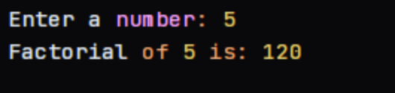
7.Fibonacci series using Recursion
#include <stdio.h>
int fibonacci(int n) {
if (n == 0) {
return 0;
} else if (n == 1) {
return 1;
} else {
return fibonacci(n-1) + fibonacci(n-2);
}
}
int main() {
int n;
printf("Enter the number of terms: ");
scanf("%d", &n);
printf("Fibonacci Series: ");
for (int i = 0; i < n; i++) {
printf("%d, ", fibonacci(i));
}
printf("\n");
return 0;
}
OUTPUT:
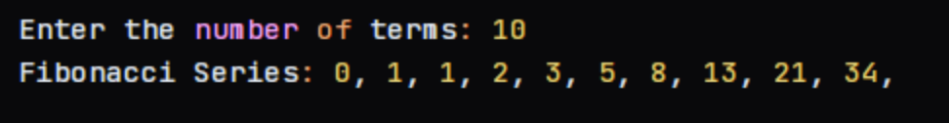
8. implement Array operations such as Insert, Delete and Display.
#include <stdio.h>
#define MAX_SIZE 10
void display(int arr[], int size) {
printf("Array elements: ");
for (int i = 0; i < size; i++) {
printf("%d ", arr[i]);
}
printf("\n");
}
void insert(int arr[], int *size, int element, int position) {
if (*size == MAX_SIZE) {
printf("Error: Array is full. Cannot insert element.\n");
return;
}
for (int i = *size; i > position; i--) {
arr[i] = arr[i - 1];
}
arr[position] = element;
(*size)++;
}
void delete(int arr[], int *size, int position) {
if (*size == 0) {
printf("Error: Array is empty. Cannot delete element.\n");
return;
}
if (position >= *size) {
printf("Error: Invalid position. Cannot delete element.\n");
return;
}
for (int i = position; i < *size - 1; i++) {
arr[i] = arr[i + 1];
}
(*size)--;
}
int main() {
int arr[MAX_SIZE];
int size = 0;
insert(arr, &size, 10, 0);
insert(arr, &size, 20, 1);
insert(arr, &size, 30, 2);
insert(arr, &size, 40, 3);
display(arr, size);
delete(arr, &size, 2);
display(arr, size);
insert(arr, &size, 50, 2);
display(arr, size);
return 0;
}
OUTPUT:
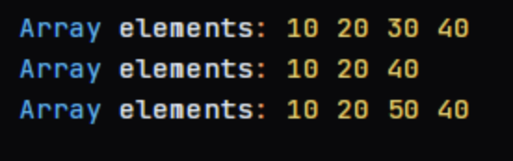
9. implement singly linked list
#include <stdio.h>
#include <stdlib.h>
typedef struct Node {
int data;
struct Node* next;
} Node;
Node* createNode(int data) {
Node* newNode = (Node*)malloc(sizeof(Node));
newNode->data = data;
newNode->next = NULL;
return newNode;
}
void insertAtBeginning(Node** head, int data) {
Node* newNode = createNode(data);
newNode->next = *head;
*head = newNode;
}
void insertAtEnd(Node** head, int data) {
Node* newNode = createNode(data);
if (*head == NULL) {
*head = newNode;
} else {
Node* temp = *head;
while (temp->next != NULL) {
temp = temp->next;
}
temp->next = newNode;
}
}
void deleteNode(Node** head, int data) {
Node* temp = *head;
Node* prev = NULL;
while (temp != NULL && temp->data != data) {
prev = temp;
temp = temp->next;
}
if (temp == NULL) {
printf("Node with data %d not found.\n", data);
return;
}
if (prev == NULL) {
*head = temp->next;
} else {
prev->next = temp->next;
}
free(temp);
}
void displayList(Node* head) {
while (head != NULL) {
printf("%d -> ", head->data);
head = head->next;
}
printf("NULL\n");
}
int main() {
Node* head = NULL;
insertAtBeginning(&head, 10);
insertAtBeginning(&head, 20);
insertAtBeginning(&head, 30);
displayList(head);
insertAtEnd(&head, 40);
insertAtEnd(&head, 50);
displayList(head);
deleteNode(&head, 20);
displayList(head);
return 0;
}
OUTPUT:
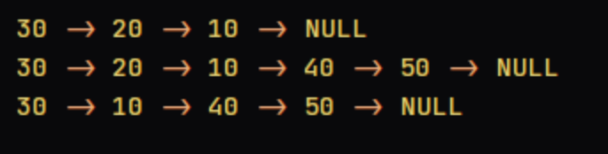
10. implement doubly linked list
#include <stdio.h>
#include <stdlib.h>
typedef struct Node {
int data;
struct Node* next;
struct Node* prev;
} Node;
Node* createNode(int data) {
Node* newNode = (Node*)malloc(sizeof(Node));
newNode->data = data;
newNode->next = NULL;
newNode->prev = NULL;
return newNode;
}
void insertAtBeginning(Node** head, int data) {
Node* newNode = createNode(data);
if (*head == NULL) {
*head = newNode;
} else {
newNode->next = *head;
(*head)->prev = newNode;
*head = newNode;
}
}
void insertAtEnd(Node** head, int data) {
Node* newNode = createNode(data);
if (*head == NULL) {
*head = newNode;
} else {
Node* temp = *head;
while (temp->next != NULL) {
temp = temp->next;
}
temp->next = newNode;
newNode->prev = temp;
}
}
void deleteNode(Node** head, int data) {
Node* temp = *head;
while (temp != NULL && temp->data != data) {
temp = temp->next;
}
if (temp == NULL) {
printf("Node with data %d not found.\n", data);
return;
}
if (temp->prev != NULL) {
temp->prev->next = temp->next;
} else {
*head = temp->next;
}
if (temp->next != NULL) {
temp->next->prev = temp->prev;
}
free(temp);
}
void displayList(Node* head) {
while (head != NULL) {
printf("%d <-> ", head->data);
head = head->next;
}
printf("NULL\n");
}
int main() {
Node* head = NULL;
insertAtBeginning(&head, 10);
insertAtBeginning(&head, 20);
insertAtBeginning(&head, 30);
displayList(head);
insertAtEnd(&head, 40);
insertAtEnd(&head, 50);
displayList(head);
deleteNode(&head, 20);
displayList(head);
return 0;
}
OUTPUT:
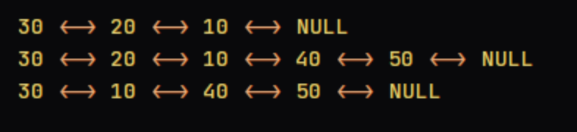
11. implement circular linked list
#include <stdio.h>
#include <stdlib.h>
typedef struct Node {
int data;
struct Node* next;
} Node;
Node* createNode(int data) {
Node* newNode = (Node*)malloc(sizeof(Node));
newNode->data = data;
newNode->next = NULL;
return newNode;
}
void insertAtBeginning(Node** head, int data) {
Node* newNode = createNode(data);
if (*head == NULL) {
*head = newNode;
newNode->next = newNode; // circular link
} else {
Node* temp = *head;
while (temp->next != *head) {
temp = temp->next;
}
newNode->next = *head;
temp->next = newNode;
*head = newNode;
}
}
void insertAtEnd(Node** head, int data) {
Node* newNode = createNode(data);
if (*head == NULL) {
*head = newNode;
newNode->next = newNode;
} else {
Node* temp = *head;
while (temp->next != *head) {
temp = temp->next;
}
temp->next = newNode;
newNode->next = *head;
}
}
void deleteNode(Node** head, int data) {
Node* temp = *head;
Node* prev = NULL;
while (temp->next != *head && temp->data != data) {
prev = temp;
temp = temp->next;
}
if (temp == NULL) {
printf("Node with data %d not found.\n", data);
return;
}
if (prev == NULL) {
Node* next = temp->next;
while (next->next != temp) {
next = next->next;
}
*head = temp->next;
next->next = *head;
} else {
prev->next = temp->next;
}
free(temp);
}
void displayList(Node* head) {
Node* temp = head;
do {
printf("%d -> ", temp->data);
temp = temp->next;
} while (temp != head);
printf("HEAD\n");
}
int main() {
Node* head = NULL;
insertAtBeginning(&head, 10);
insertAtBeginning(&head, 20);
insertAtBeginning(&head, 30);
displayList(head);
insertAtEnd(&head, 40);
insertAtEnd(&head, 50);
displayList(head);
deleteNode(&head, 20);
displayList(head);
return 0;
}
OUTPUT:
